**JINNAH UNIVERSITY FOR WOMEN**



**DEPARTMENT OF COMMERCE**

**ASSIGNMENT # 02**

Communication Process

**SUBMITTED BY**

Wajiha Muhammad Ismail

**DEGREE PROGRAM**

BS (II)

**SUBJECT**

Business Communication

**SUBMISSION DATE**

Sept 12, 2020

**SUBMITTED TO**

Miss Uzma

# **Communication**

Communications is the essential part of an organization. It helps organization to survive and make an effective existence. It is the process of creating and sharing the information, views, ideas between the people.

Communication is the key element of the management for running the functions. If a manager is highly qualified and good at everything but not in communication then all his abilities are irrelevant because to achieving an organizational goals properly a manger must have to be communicate effectively to their subordinates.

# **Communication Process**

It is a continuous process which contain three major elements including sender, message and receiver are explained below:

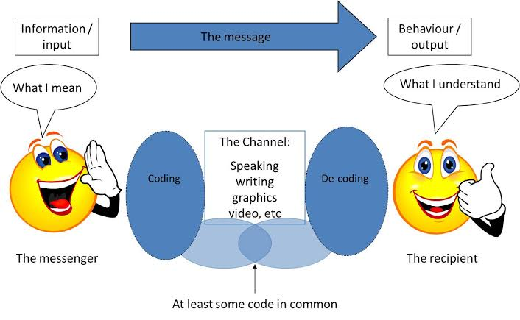

1. **Sender or The messenger**

A sender is someone who starts communication by generating and conveying the message to receiver.

2. **Message**

It is the content containing ideas, information, views, feelings etc. generated by a sender.

3. **Encoding**

A sender is also known as encoder who generates or encodes the message with the help of symbols. For example: pictures, gestures, videos etc.

4. **Media**

A media is a source choose by sender through which he transmits his message to the receiver. A message may transmitted orally or in written form through internet, fax, email, telephone etc.

5. **Decoding**

A receiver is also known as decoder. The one who converting or decoding the message encoded by sender. When a decoder decodes the message, it is received by the receiver.

6. **Receiver or The recipient**

A receiver is someone who receives the message, understand it properly, and act accordingly, then the goal of communication is successful.

7. **Feedback**

When a receiver receives the message and confirm to the sender that he receives and understood it properly. Here is the communication process comes to an end.

8. **Noise**

Noise is defined as any obstruction caused by sender, message or receiver during communication process. For example: Internet issue, less understanding message, irrelevant words etc.